Empirical benchmarks on racial underrepresentation in Hollywood from available content analysis data

Here I’ll try to summarise the state of knowledge from empirical content analyses concerning relevant questions of character prevalence by race/ethnicity, Latina representation, and behind-the-camera diversity. The three main sources are all annual content analyses which look at top-grossing releases each year. Each uses a slightly different method.

The sources are:

* Martha Lauzen (of San Diego State’s Center for the Study of Women in Television and Film). 2020. “It’s a Man’s Celluloid World” report. Available from [here](https://womenintvfilm.sdsu.edu/research/).
* Stacy Smith et al (of the Annenberg Inclusion Initiative at USC). 2019. “Inequality in 1,200 Popular Films: Examining Portrayals of Gender, Race/Ethnicity, LGBTQ & Disability from 2007 to 2018” report. Available from [here](https://annenberg.usc.edu/research/aii).
* Darnell Hunt et al (of UCLA). 2020. Hollywood Diversity Report. Available from [here](https://socialsciences.ucla.edu/hollywood-diversity-report-2020/).

Lauzen’s and the Inclusionists’ studies are much more similar in methods, the main difference being that Lauzen’s is more narrowly focused on gender and is much less detailed in its discussion. The Hollywood Diversity Report is qualitatively different from both, using different measures (e.g. it measures film leads and total film actors, where the first 2 studies focus on speaking characters) and looking over a two-year period, with more of a focus on the industry and the bottom line.

**On-screen prevalence:**

Overall, the proportion of characters that are white seems to be coming down, though the gains seem to be concentrated among Black characters.

Martha Lauzen’s breaks this down by gender, finding the following trend for female characters (with similar numbers for men - the main difference being that Black men are less prevalent than Black women):

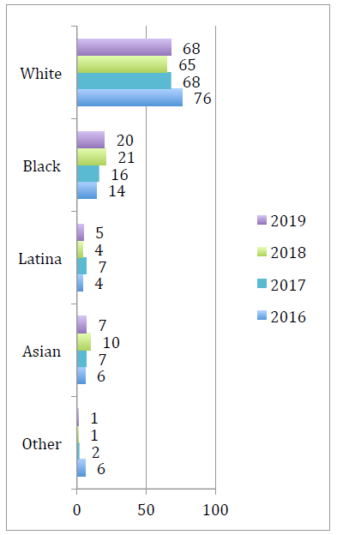

While the Annenberg Inclusion Initiative reports that, overall:

The percentage of white characters has decreased significantly in 2018 (63.7%) in comparison to 2017 (70.7%) and 2007 (77.6%). Black characters were at a 12-year high in 2018, though the percentage was just shy of a 5 percentage point difference (+4.8) between 2018 and 2017. A 3.9 percentage point difference was observed from 2007 to 2018 in the percentage of Black characters.

For Asian speaking characters, 2018 (8.2%) was higher than 2007 (3.4%) but just short of the 5 percentage point difference demarcating meaningful change. 2018 (8.2%) was slightly higher than 2017 (4.8%).

They suggest that “In total, 36.3% of speaking characters were from underrepresented racial/ethnic groups which approximates U.S. Census (39.6%)”, which is a weird way of wording that.

Here’s the Hollywood Diversity Report figures (first, “film leads”, followed by share of all actors):

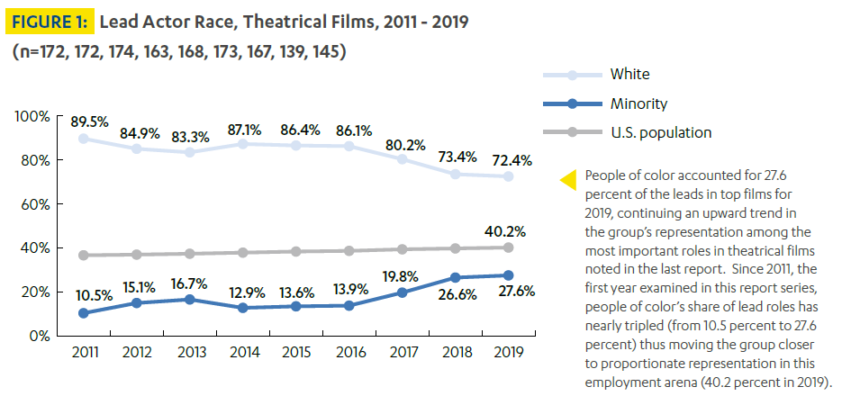

Table . Overall cast diversity by racial group 2016-2019 (Source: Hollywood Diversity Report).

|  |  |  |  |  |
| --- | --- | --- | --- | --- |
| Group | 2016 | 2017 | 2018 | 2019 |
| White | 78.1% | 77.0% | 69.1% | 67.3% |
| Black | 12.5% | 9.0% | 14.9% | 15.7% |
| Latinx | 2.7% | 5.2% | 4.9% | 4.6% |
| Asian | 3.1% | 3.4% | 4.8% | 5.0% |
| Multi | 3.0% | 5.0% | 5.4% | 6.2% |
| Native | 0.5% | 0.4% | 0.3% | 0.5% |
| MENA | - | - | 0.7% | 0.7% |

Again, it looks like the declining White share is reflected in annual gains are present for Black, Asian and Multi/Mixed groups, but not so much for Latinx.

**On Latina characters:**

The Inclusion Initiative finds Latina characters to be hypersexualised disproportionately (where this is measured via characters “shown in sexually revealing attire”, shown “with some nudity”, and being “referenced as attractive by other characters”). They find:

In 2018, Latinas were the most likely to be hypersexualized – as measured by sexy attire or some nudity – in comparison to females in 4 other groups (white, Black, Asian, other). Females from other racial/ethnic backgrounds were the most likely to be referenced as attractive, particularly in comparison to females that were Black, Asian, or Latina. There were no meaningful differences across the three hypersexualization indicators by race/ethnicity for male characters.

They also find that Latina characters were missing from 70 of the 100 top-grossing films in 2018, compared with 54 which didn’t feature Asian/Asian-American female characters, 33 which didn’t feature Black women, and 51 which didn’t feature females from other/multiracial backgrounds. They report that “Erasure in 2018 was higher than in 2017 (64) for Latinas and does not differ from 2015 (65)”.

Interestingly, Latinas seem to be the only minority ethnic group for whom visibility isn’t increasing:

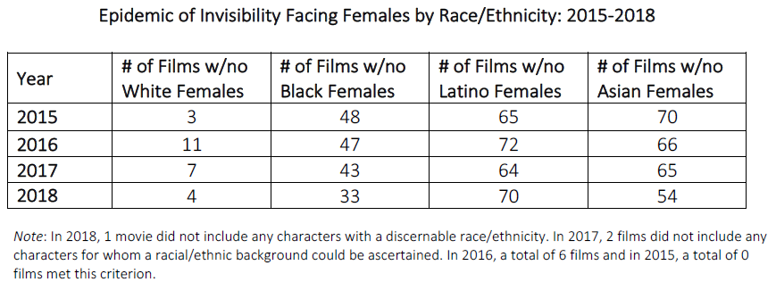

**On genre:**

The Inclusionists find that:

The percentage of underrepresented characters was at a 12-year high in action/adventure movies (40.3% of all speaking characters). 2018 is 12.2 percentage points higher for underrepresented characters than 2017 (28.1%) and 18.8 percentage points higher than 2007 (21.5%).

They only seem to collect data on action/adventure, animation and comedy. I didn’t love the way they presented the trends so I graphed it out:

To me, this shows that action/adventure films have maintained a pretty flat rate of non-white prevalence – 2018 may be an anomaly given the consistency of the 2008-2017 figures – while there is a much clearer upward trend in animation and, to a lesser extent, comedy.

Overall, the Hollywood Diversity Report finds that the action genre surpassed drama as the single most common genre in their top-grossing list in 2017, and has increased its lead year on year since, now accounting for a quarter of the top-grossing films in 2019. (Note that their annual list selects the top 200 theatrically released films ranked by global box office and then removes foreign language films).

It would be great to have more figures on character prevalence by both genre and race/ethnicity. I’ll see if I can turn any up in the peer-reviewed content analyses, which tend to be one-off studies rather than annual state-of-play reports, but might contain useful numbers for identifying a benchmark.

**Behind the camera:**

On race of directors, the Inclusionists report that:

Fifteen directors (13.4%) in 2018 were Black, with 14 males and 1 female. 2018 represents a historic high in hiring Black directors. This is primarily accounted for by the fact that Sony hired 4 Black directors to helm top motion pictures in 2018. Over the 12 year sample, only 79 (5.9%) of 1,335 top jobs were held by Black directors.

…

Of the 112 directors of 2018, only 4 were Asian. This is only 3.6% of the entire sample of directors working across the 100 top fictional films. None of the 2018 directors were Asian women. No over time changes have been observed from 2007 to 2018. Only 3 jobs have been allotted to Asian female directors over the 12 years evaluated.

Only 3 directors were Latino and 4 MENA across the 100 top films of 2018.

The trends in white vs non-white director prevalence are offered in the Hollywood Diversity Report:

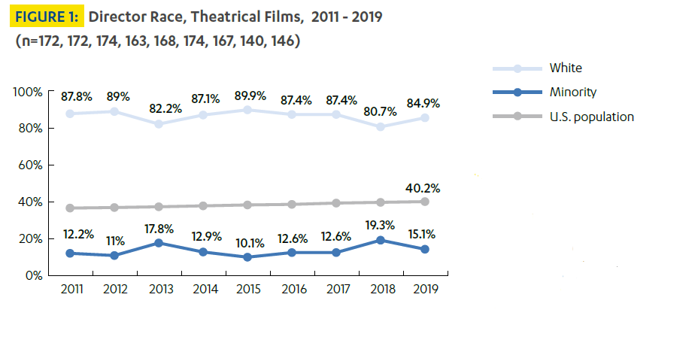

And here’s that “Minority” category collapsed into groups for 2018 and 2019:

|  |  |  |
| --- | --- | --- |
| Group | 2018 | 2019 |
| White | 80.7% | 84.9% |
| Black | 10.7% | 5.5% |
| Latinx | 0.7% | 2.7% |
| Asian | 4.3% | 3.4% |
| Multi | 2.9% | 2.7% |
| Native | 0.0% | 0.0% |
| MENA | 0.7% | 0.7% |

Here’s the same graph for writers:

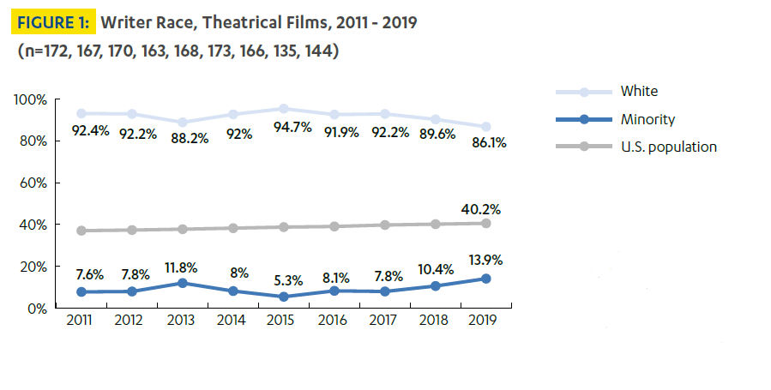

It’s probably less directly relevant for our purposes, but worth noting that the Hollywood Diversity Report finds that, among the 11 major and mid-major studios:

The heads of these studios (“Chair/CEO”) were 91 percent White and 82 percent male. A level down in the hierarchy (“Senior Executives”), the senior management teams were 93 percent White and 80 percent male. And while the executives responsible for casting, marketing, legal and other core studio functions (“Unit Heads”) were a little more diverse in terms of gender (only 59 percent male), they too were overwhelmingly White (86 percent).

This is not only out of keeping with the US population, but with the movie-going audience – they find that “In 2019, people of color were responsible for the majority of domestic ticket sales for eight of the top 10 films [up from 6 of the top 10 in 2018 and 5 in 2017], ranked by global box office, and half of the ticket sales for a ninth top 10 film” – the greatest share among these 10 films was for *Fast & Furious Presents: Hobbs & Shaw* (60% minority audience). They also find that Latinx and Asian viewers are overrepresented among frequent movie-goers and Whites underrepresented relative to population proportions.